BI1I – PROBLEM SET 04 (90 pts)
Winter Term 2026
Released: Feb 28, 2026
Due: Mar 06, 2026 (midnight)

These questions are meant to sharpen your understanding of the content discussed in class. We hope these questions are engaging enough to encourage collaboration and discussion with your fellow classmates; however, you are each expected to submit individual answer sheets, written in your own words. Please cite any outside sources that you use – at times, these questions walk through specific examples that are outside the scope of the lecture slides, so we expect you to consult textbooks and/or published works/reviews. As described in the course policies, you can NOT use ChatGPT or other AI platforms to write your answers, zero tolerance.

Problem 1: Revisiting TCR signaling with a more nuanced understanding (40 pts)

First, let’s review some of the content discussed in class.

a. In the thymus, T cells go through an extensive selection process that depends on the strength of their TCR binding to MHC-antigen complexes. Describe the fate of the T cell with each of the signaling strengths described below. Why would B cells not benefit from the same selection process that T cells go through (make sure to address differences in BCR vs TCR diversification in your explanation)? 6 pts

No TCR binding to MHC-antigen:
Medium level TCR binding to MHC-antigen:
Extremely strong TCR binding to MHC-antigen:

T cells exit the thymus as “naïve” T cells and enter lymph nodes, where they can meet antigen presenting cells. However, we learned in class that TCR signaling alone is not enough to “activate” naive T cells.
b. Describe all of the signals that are required to activate naive T cells. In your description, make sure to keep track of which receptors/ligands are present on the T cell and what other cell types are involved. Feel free to draw a picture with specific receptors/ligands if this makes more sense to you, but make sure to still clearly state what each signal refers to in general terms. (these activation requirements are commonly referred to as “signal 1”, “signal 2” and “signal 3”) 6 pts

c. Conversely, B cells are not activated in the same way T cells are. How are B cells activated? Specifically describe the receptors/ligands and other cell type(s) involved. 4 pts

Based on your answers above, it should be clear that B cells and T cells rely on other cell types to launch a proper response to an immunological threat. This is a critical concept in immunology, as it speaks to the necessary communication between the adaptive immune system and innate immune system. In fact, the immunologist’s “dirty little secret” is crucial for vaccine development.
Recall: vaccinations often administer little harmless bits of pathogens to preemptively stimulate the adaptive immune system and generate memory T/B cells for future encounter of the pathogen in its full form. The immunologist’s dirty little secret is that the introduction of pathogen-related peptides in their purified form is not enough to stimulate a preemptive immune response; vaccinations require the addition of an adjuvant, or a substance/mixture containing general bacterial extracts or specific molecules (DAMPs/PAMPs = “damage associated” or “pathogen associated molecular patterns”).
d. Using your knowledge of B cell/T cell activation requirements and knowledge of immune cell recognition mechanisms, explain why adjuvant might be necessary for activating the adaptive immune system. 6 pts

Going back to the T cell’s journey: as discussed in class, after a naïve T cell encounters an antigen presenting cell (APC) where its TCR binds the APC’s MHC-antigen complex, they can either become effector T cells, memory T cells or exhausted T cells.
e. Explain what each of these 3 fates means for the T cell and compare their differing activation requirements. 4 pts

f. What are the pros and cons of having this higher barrier for T cell activation? (In other words: why would it be bad to have a low threshold for T cell activation? Is having this high threshold a “bad” thing? ) 4 pts
In the last problem set, we zoomed in on the TCR-calcium-NFAT pathway. In thinking about T cell exhaustion, you might be wondering how TCR signaling can activate NFAT but not activate the effector functions usually associated with NFAT?
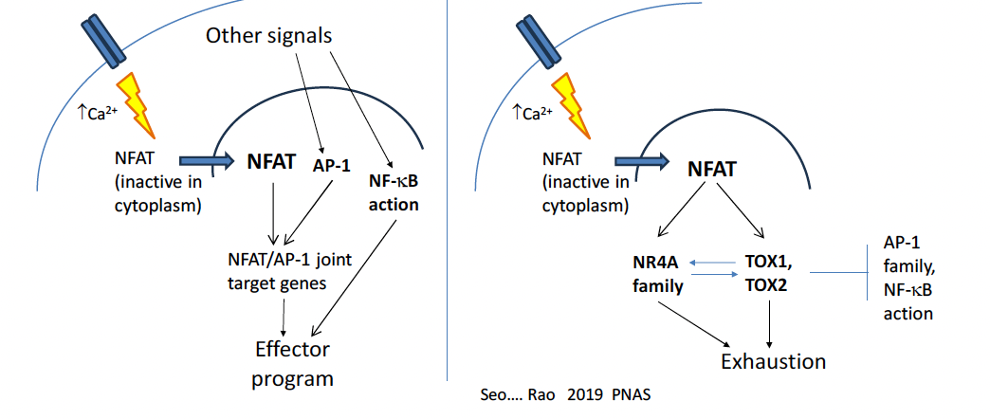
We briefly mentioned this in class, but there is a neat, proposed mechanism to address this question. Being in Bi1i, you know that transcription factors (TFs) like NFAT never really act alone. The presence or absence of other potential binding partners (other TFs) at specific timepoints and at specific concentrations greatly influences TF activity, and NFAT is no exception. Interestingly, NFAT’s activation of effector genes relies on the presence of another transcription factor, AP-1 (diagram above).
This is because many of the genes in the effector program rely on regulatory elements that benefit from the synergistic binding of AP1 and NFAT. These regulatory elements contain binding motifs for both AP-1 and NFAT. As you may recall: although transcription factors prefer ideal binding motifs, the motifs they actually bind in the cell do not always have to be perfect (can be a nucleotide or few off). So, the presence of AP-1, which is downstream other signaling cascades including pathways initiated by costimulatory molecules, pulls NFAT towards their joint motifs, which don’t necessarily contain “perfect” NFAT motifs, to ultimately activate effector genes (left part of diagram).
On the other hand, without AP-1, NFAT does not bind these joint AP-1/NFAT binding sites, and these other binding sites happen to activate the “exhaustion program” and can even repress AP-1 and NF-kB activity (right part of diagram).
Considering the requirements for T cell activation discussed in part b, you become interested in modeling the decision to become an effector vs. exhausted T cell.
g. What would you hope to capture with your model; in other words, what question would you hope to answer with your model? What variables would you want to include? With such a high dimensional space, would you choose to narrow your model to a subset of the system? Or would you attempt to embrace all the complexity? What assumptions might you make and what would you be weary of in making your model? What type of experimental data would you hope to incorporate to verify and test your model? (You don’t need to actually propose a mathematical model, but we hope to encourage creativity with this question now that you have covered a lot of the course content so take it as far as you would like to! There is no “correct” answer, just make sure to explain your thought process and understanding of the biology at play) 10 pts

Problem 2. Cancer Vaccines and T cells. (30 pts)

The expression of cancer/testis (CT) antigens is normally limited to human germ line cells in the testis and to various types of human cancers. A type of a CT antigen is the melanoma-associated antigen gene (MAGE) family. Although MAGE was first discovered in melanoma cells (pigment cells), it is also expressed in testis and in cancer.
MAGE is known to induce spontaneous humoral and cellular immune responses in MAGE-expressing cancer patients, with the result that they are feasible targets for tumor immunotherapy.

MAGE-A4 is also reported to be expressed in a wide variety of tumors, e.g., 60% esophageal cancer, 50% head and neck cancer, 24% non-small-cell lung cancer, 33% gastric tumor, and 21% Hodgkin's disease, but not in normal tissues besides the testis. MAGE-A4 elicits spontaneous humoral or cellular immune responses in patients with MAGE-A4-expressing non-small-cell lung cancer, head and neck cancer, and adult T cell leukemia/lymphoma. Many MAGE-A4 epitope peptides recognized by CD4 and CD8 T cells by MHC class I and class II have been identified.

In this study, the researchers conducted a cancer vaccine clinical trial with a complex of MAGE-A4 protein and cholesteryl pullulan (CHP) nanoparticles in advanced cancer patients. They monitored and analyzed the safety, clinical effect, humoral and cellular immune responses, and expression of antigens in these patients.

The authors “analyzed the ratio of CD4+ Foxp3 high+ cells in CD3+ T cells at baseline from 15 vaccine-completed patients. Patients with a low ratio of CD4+ Foxp3 high+ cells in CD3+ T cells showed longer overall survival than patients with a high ratio after vaccination, although it was not significant.”

a. Based on what you learned in class, what is the general name for CD4+ Foxp3+ T cells? Describe how this specific subset T cells contributes to the immune system. 4 pt

Let’s consider how the transcription factor Foxp3 allows this specific subset of T cells to perform their immunological functions. Foxp3 is known to drive the expression of:
- CTLA-4
- CD25
- IL-10 and TGF-β

b. Explain why Foxp3-driven expression of these targets above allows CD4+Foxp3+ cells to perform their immunological role, as you described in part a. 6 pt

c. Now going back to the results of the MAGE-4/CHP treatment –the small sample size prevented the effect seen from being statistically significant, but if the trend were to continue in a larger sample, what would this result say about the impact of CD4+ Foxp3+ T cells on the cancer vaccine treatment? Why might this result make sense from an immunological perspective? 4 pt

Interestingly, two stable disease patients, P-6 and P-12, belonged in the low ratio group (patients with lower levels of CD4+ Foxp3+ T cells). Looking specifically at P-12 from the study, flow cytometric analyses were performed before and after the vaccination. In this case, flow cytometry was used to measure cytokine production.

A common immunology method (that was not covered in class in extensive detail) is an Intracellular Cytokine Staining (ICS) assay. It is a method used to measure cytokine production in individual cells via flow cytometry. It is primarily used to evaluate T cell function by detecting cytokines like IFN-γ, IL-2, and TNF-α that have accumulated inside the cell.
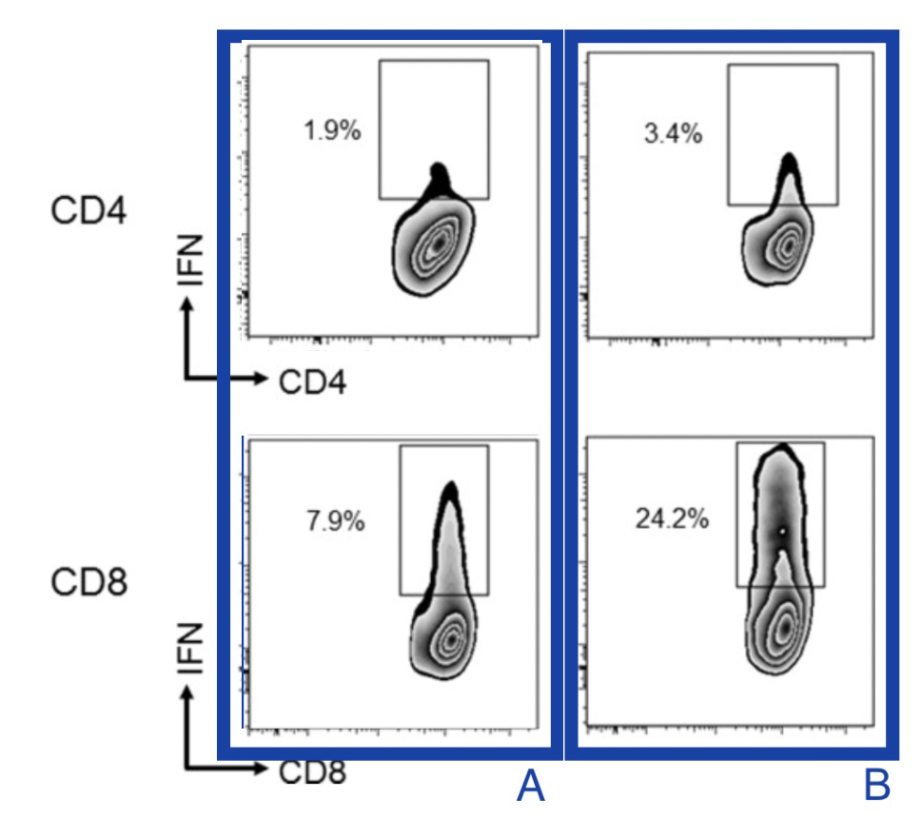
In the following figure, MAGE-A4-specific CD4 and CD8 T cell responses were analyzed by an Intracellular Cytokine Staining (ICS) assay using peripheral blood mononuclear cells (PBMCs) obtained from 15 vaccine-completed patients at baseline and 2 weeks after the 6th immunization. Specifically, CD4 and CD8 T cells were isolated from PBMCs and were then grown together with antigen-presenting cells (APCs) that had been loaded with 31 different overlapping pieces of the MAGE-A4 protein. CD4 T cells were cultured for 21 days, and CD8 T cells were cultured for 8 days. After this growth period, the T cells were collected and stimulated again for 6 hours using APCs loaded with the same MAGE-A4 peptides or with a control (unrelated) peptide. Finally, the researchers measured how many CD4 or CD8 T cells produced interferon-gamma (IFN-γ) using an intracellular cytokine staining (ICS) assay. For their control, CD4 and CD8 T cells were stimulated with APCs loaded with an irrelevant peptide instead of the MAGE-A4 peptide pool (not shown here).

d. The flow cytometry plots to the right show T cell samples that were processed as described above either before the vaccination (A) or after the vaccination (B) where IFN refers to interferon-gamma (IFN-γ). Explain what these results mean, and what they reveal about vaccine impact of CD4/CD8 activity. 2 pt

The following graphs show MAGE-A4 antibody response analyzed by enzyme-linked immunosorbent assays (ELISAs) using recombinant MAGE-A4 protein with a His-tag, which is used to obtain purified MAGE-A4 protein from a messy sample.

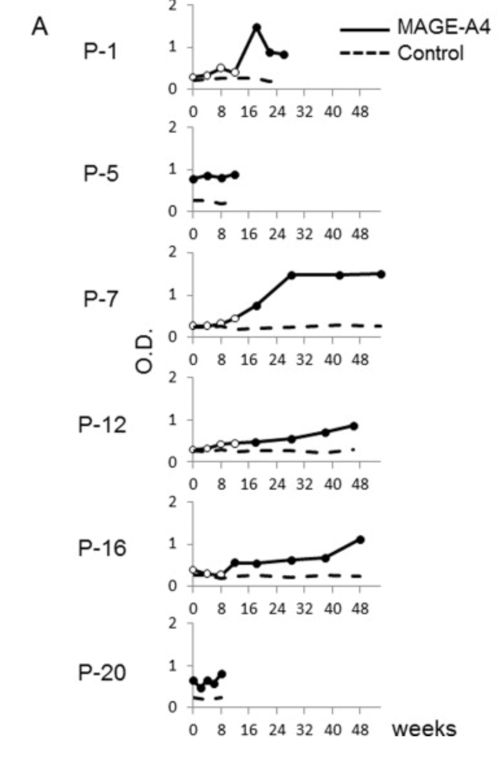
The His-tag technique is a streamlined method for isolating a specific protein by genetically adding a short string of histidine residues (usually 6xHis) to its structure, creating a high-affinity "handle." This tag allows the protein to selectively bind to nickel or cobalt ions immobilized on a resin during Immobilized Metal Affinity Chromatography (IMAC). While the target protein remains stuck to the beads, unwanted cellular debris is washed away; the purified protein is then "freed" or eluted using imidazole, a molecule that mimics the tag and outcompetes it for the metal binding sites. A His-tag was used in the ELISA experiment because for ELISA, large amounts of clean protein are needed so the His-tag makes production and purification practical.The ELISA assay results to the right measure MAGE-A4 antibody levels is blood serum.
In ELISA assays, purified protein (in this case MAGE-A4) are coated on the bottom of a plate that contains multiple wells. Blood serum samples are then added to specific wells (notated as P-1, P-5, etc. to the right). If there are antibodies that bind MAGE-A4 in the patient serum, they bind to the antigen coating the bottom of the wells. The samples are washed so only antigen-bound antibodies remain, and then secondary antibodies are added which are conjugated to enzymes. A substrate is then added, which the enzymes react with to create a colored signal. This colorimetric signal is thus red as an optical density measurement (OD, measured on the y-axis in the plots).

In this case, ovalbumin (OVA) was used as the control protein. OVA is a model antigen that comes from chicken egg whites and is the main allergen that causes egg white allergies. At every time point, patient samples were added to control wells that were coated in purified OVA protein and test wells that were coated in purified MAGE-A4 protein. Vaccine treatment was administered at the 0 timepoint.

e. Based on the description of the experiment above, what does a higher OD value indicate about the patient sample? What OD measurements would you expect for the OVA control wells? 4 pt

f. Do you observe patient(s) who already have immunity against MAGE-A4? Which patient(s)? What do the results say about the other patients? Explain how you reached your conclusion. 4 pt

After this experiment was done, Anti-MAGE-A4, but not anti-His-tag, antibody responses in sera from patients P-1, P-12, and P-16 were analyzed by Western blot analysis using recombinant MAGE-A4 protein without any tags.

f. Why did the researchers specifically focus on Anti-MAGE-A4, but not anti-His-tag antibody responses, for this experiment? Why were anti-MAGE-A4, but not anti-His-tag proteins, used in the previous ELISA experiment? 2 pt

g. Interpret the results from the Western (shown below, where “pre” means before vaccine treatment and the 18w/46w/48w column indicates the weeks after vaccine treatment). Do the results agree with the results from the ELISA? 4 ptow ratio of CD4+ F
oxp3 high+ cells in CD3+ Tells 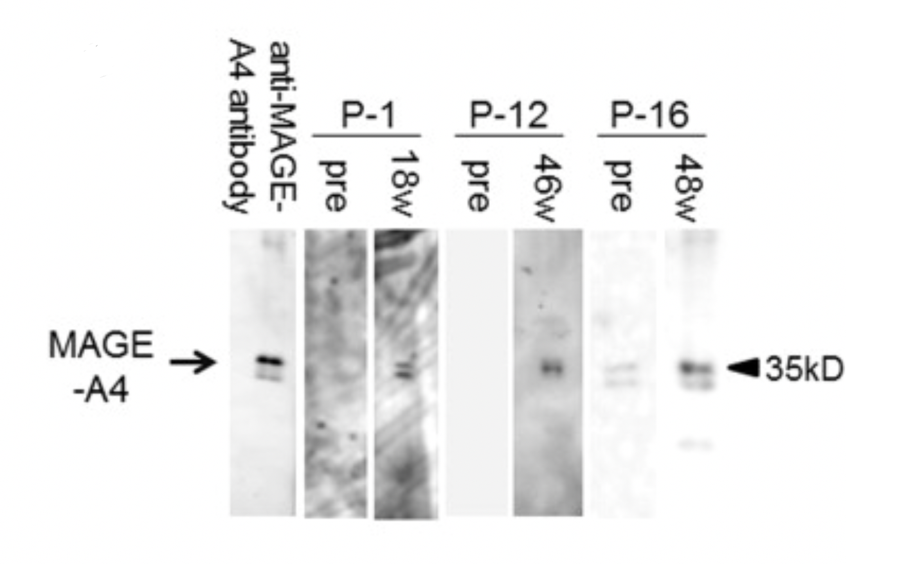

Extra Credit (you are not required to do the following part of Question 2):
Another important use of immunocytes for targeting cancers are Tumor-infiltrating lymphocytes (TILs). TILS are naturally occurring white blood cells (T cells) that have migrated from the bloodstream into a tumor to recognize and attack cancer cells. While they are "battle-hardened" soldiers already trained to identify a patient's specific cancer, they are often too few in number or become "exhausted" by the tumor's defenses to effectively eliminate the disease on their own.

A patient with metastatic (or the cancer had spread to other organs) colorectal cancer was found to harbor a KRAS G12D mutation. The KRAS G12D mutation is a highly prevalent oncogenic driver where the amino acid glycine is replaced by aspartic acid at codon 12 of the KRAS protein. This single-site transition results in a bulky, negatively charged side chain that stabilizes the protein in a constitutively active "ON" state, driving uncontrolled cell proliferation and survival.

Tumor-infiltrating lymphocytes (TILs) isolated from this patient’s lung metastases were shown to recognize a peptide derived from the mutant KRAS protein. T cells enriched for this specificity were expanded ex vivo, and after chemotherapy that depleted lymphocytes (lymphodepleting), the patient was infused with 10¹¹ T cells (75% CD8+ and the remaining were CD4+). High-dose IL-2 was administered after infusion. Most metastatic lesions regressed, although one lesion later progressed. Going back to KRAS, it is a self-protein, but the G12D mutation alters its amino acid sequence. This creates a neoantigen which is a mutant peptide not present during thymic selection, thus allowing T cells specific for the mutated epitope to exist and recognize tumor cells presenting that peptide on MHC class I. The lung metastases were removed to obtain tumor tissue containing tumor-infiltrating lymphocytes. These TILs were screened to identify and expand clones specifically recognizing the KRAS G12D mutant peptide. Lymphodepleting chemotherapy removes regulatory T cells and competing endogenous lymphocytes, increases availability of homeostatic cytokines (IL-7), and improves engraftment and expansion of the infused tumor-specific T cells.

h. Why was IL-2 administered after infusion of the expanded T cells? Extra Credit 1 pt

i. One lesion later progressed despite initial regression of others. Provide two possible immunological explanations for this escape. Extra Credit 2 pt

Problem 3: Let’s Review! (20 pts)
There is no throughline for this question, we will just touch on various concepts discussed throughout the course to refresh your memory!

a. SNPs, or single nucleotide polymorphisms, are spontaneous genomic sequence variations, some of which can increase the frequencies of certain diseases. As the name suggests, SNPs involve a mutation of a single nucleotide (including a nucleotide insertion, deletion, replication, etc.) PCR can be used to detect the presence of specific SNPs. Describe PCR and why it would be a useful detection tool in the context of SNPs. What design considerations must you take into account (primers)? 5 pts

b. When you look at a genome browser software (eg: UCSC genome browser), you might see promoters, enhancers, exons and introns. At which of these 4 regions would you expect to see RNA-sequencing data? At which of these 4 regions would you expect to see ChIP-seq data for a target transcription factor? At which of these 4 regions would you expect to see ATAC-sequencing data, where the presence of peaks indicates “open” chromatin regions? Please explain your reasoning and keep in mind that the answer does not have to be just 1 of the 4 options. 4 pts

c. The classic symptoms of inflammation involve heat, swelling, redness and pain; on a cellular level, inflammation creates a local microenvironment filled with pro-inflammatory cytokines and chemokines that draw in innate immune cells. Describe at least 3 cell types involved, and how they contribute to this inflammatory response. 5 pts

d. B cells have different mechanisms for generating diversity in their BCRs. List all 4 mechanisms and fully describe at least 2 of these 4 mechanisms, making sure to describe what these mechanisms are, why they are important for generating diversity, and at what timepoint these mechanisms occur in a B cell’s lifetime. 4 pts

e. Most “mature” or “terminally differentiated” cells in your body are not able to proliferate. Why is it important that T cells and B cells still maintain proliferative ability? 4 pts

